CEPH-LAB

,,,,,,,,,,,,,,,,,,,,,,,,,,,,,

## Nodes Setup

1. Create 5 nodes with 1 GB RAM and 1 core CPU each. Let's denote them as follows:

* ceph-controller

* ceph-compute01

* ceph-compute02

* ceph-monitor

* ceph-client

2. Attach 3 disks of 20 GB each to `ceph-compute01` and `ceph-compute02`.

vim /etc/hosts

rsync /etc/hosts [root@192.168.15.187:/etc/hosts](mailto:root@192.168.15.187:/etc/hosts)

rsync /etc/hosts [root@192.168.15.187:/etc/hosts](mailto:root@192.168.15.187:/etc/hosts)

rsync /etc/hosts [root@192.168.15.187:/etc/hosts](mailto:root@192.168.15.187:/etc/hosts)

systemctl stop firewalld && systemctl disable firewalld

run all nodes

yum install chrony -y

chronyc sourcestats

Create a user for Ceph deployment and disable its password:

useradd cephadm && echo "cdac" | passwd --stdin cephadm

Allow cephadm user to run sudo commands without a password:

echo "cephadm ALL = (root) NOPASSWD:ALL" | sudo tee /etc/sudoers.d/cephadm

chmod 0440 /etc/sudoers.d/cephadm

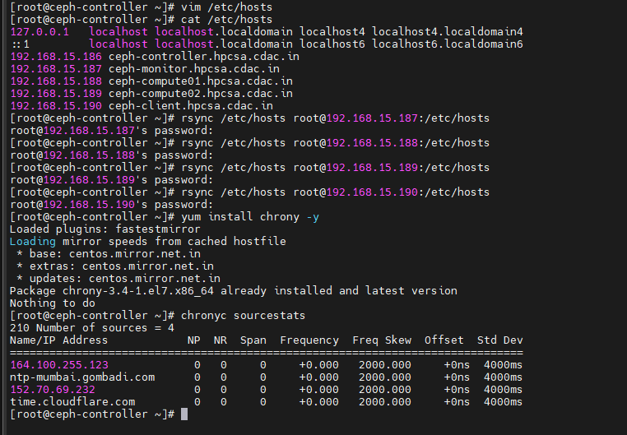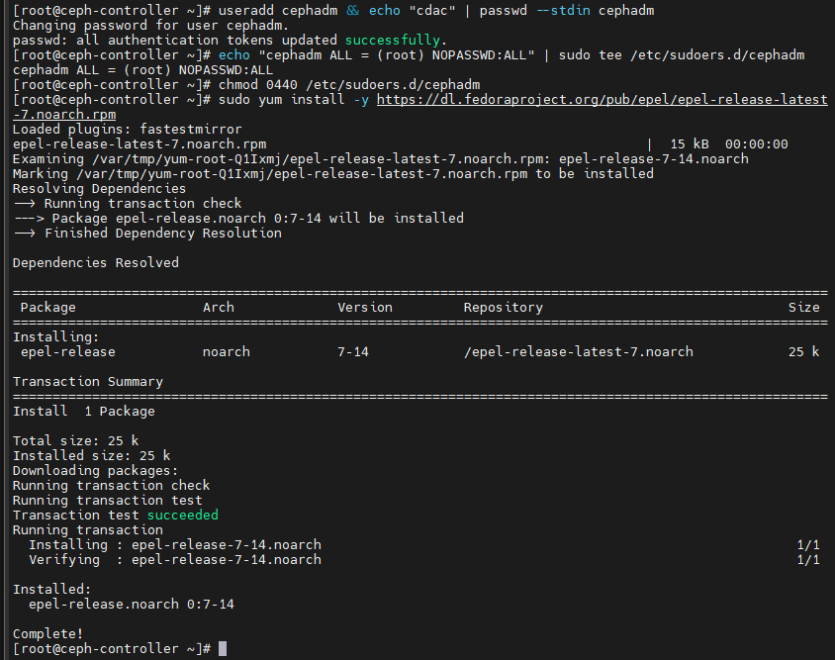

Run on all nodes

sudo yum install -y <https://dl.fedoraproject.org/pub/epel/epel-release-latest-7.noarch.rpm>

reboot

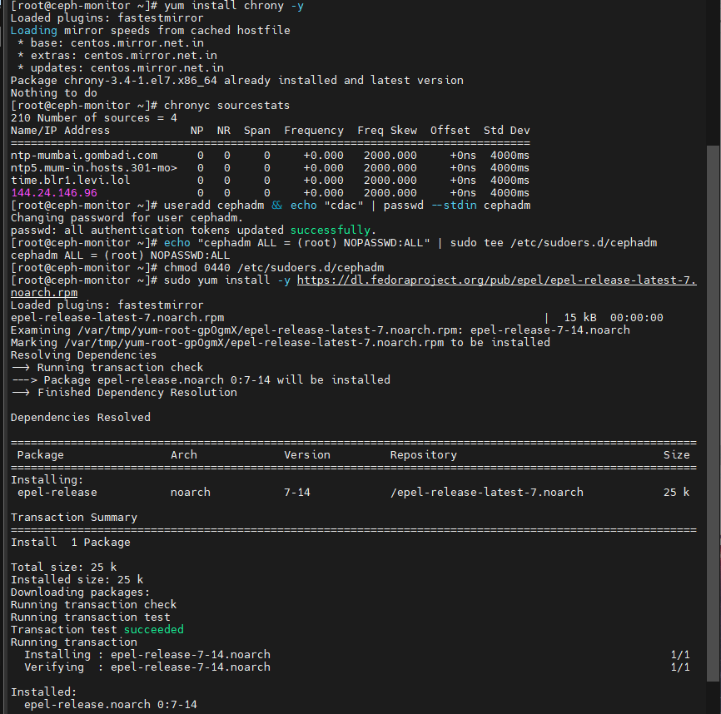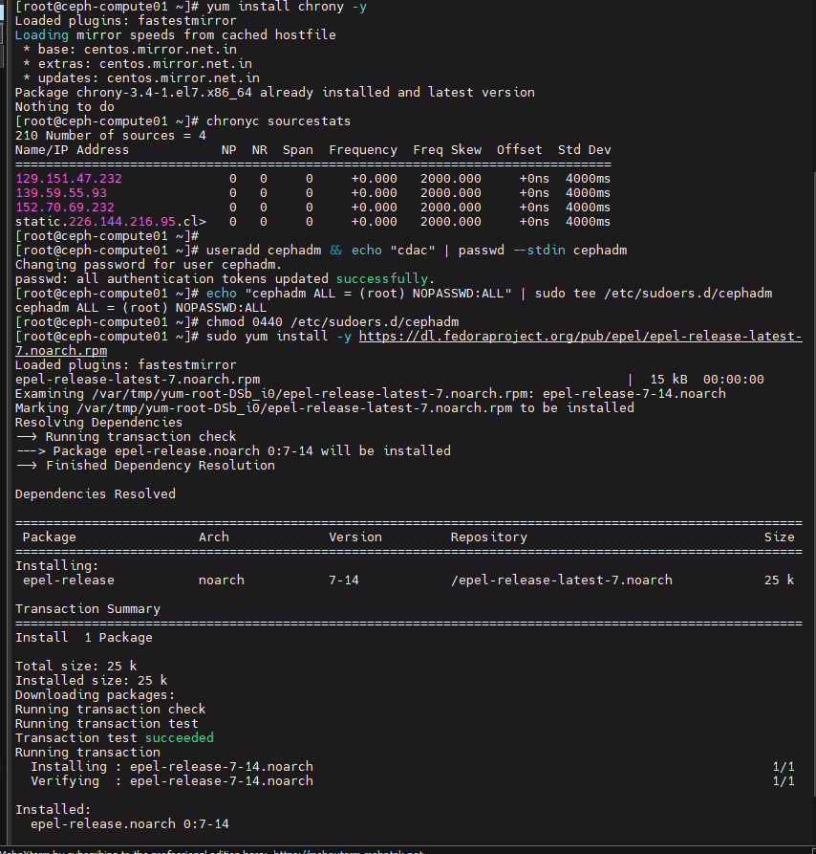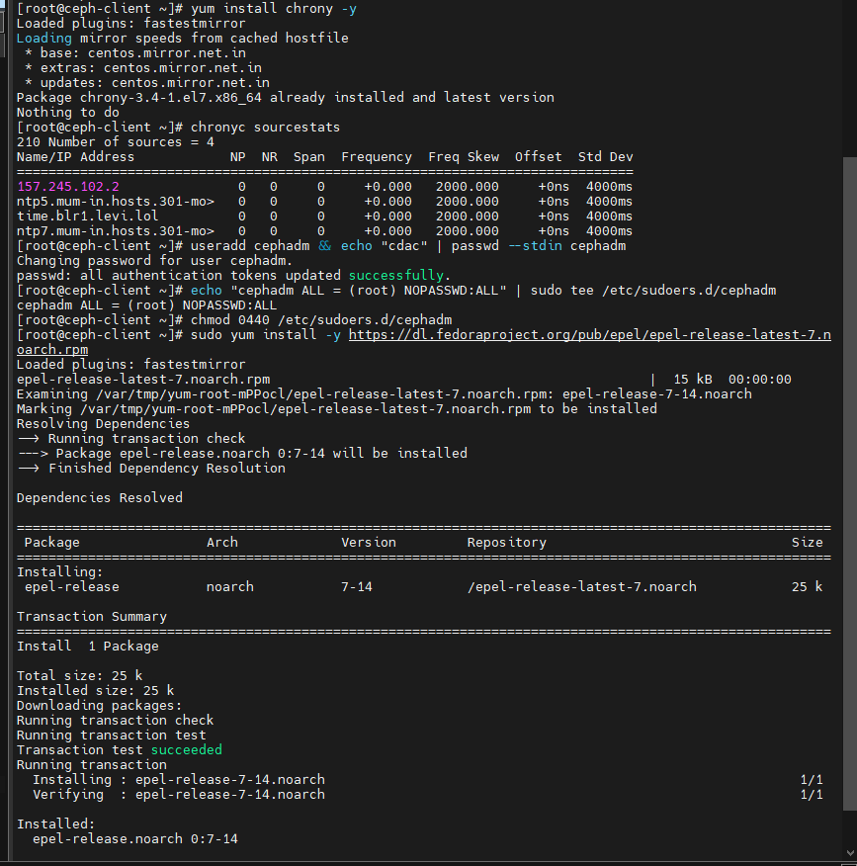

## Chrony Configuration (Execute these commands on all nodes except ceph-controller)

Modify the chrony configuration:

vim /etc/chrony.conf

Comment all available servers and add the line `server ceph-controller`.

systemctl restart chronyd

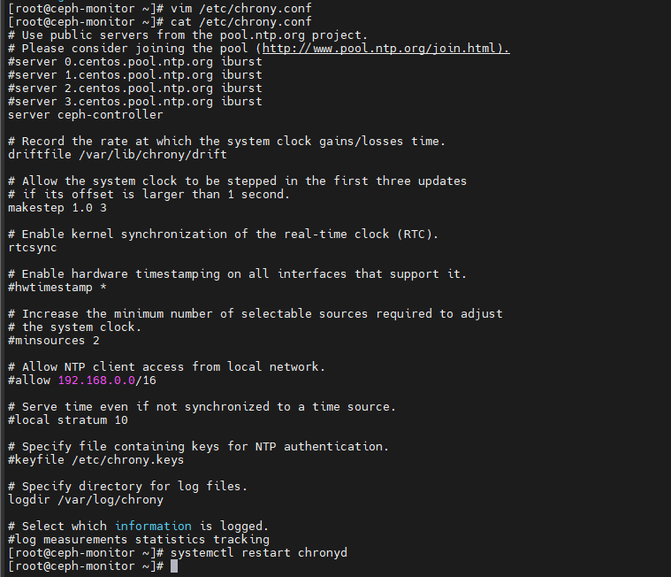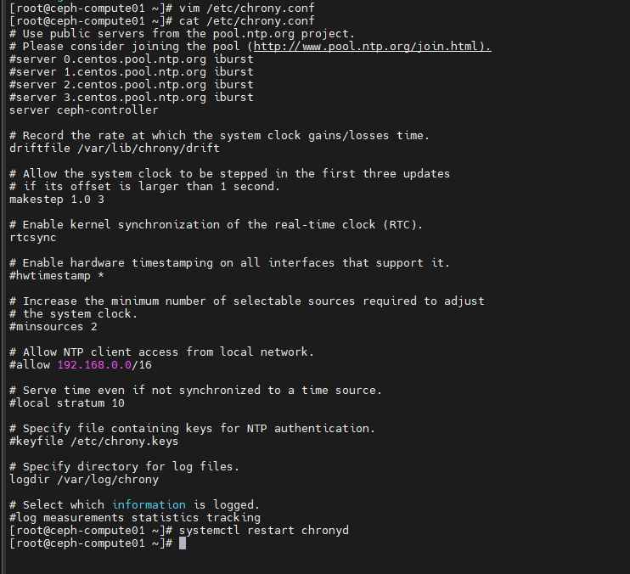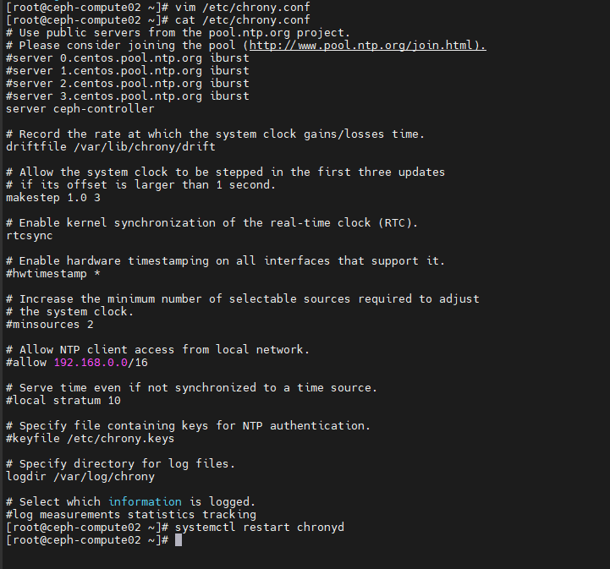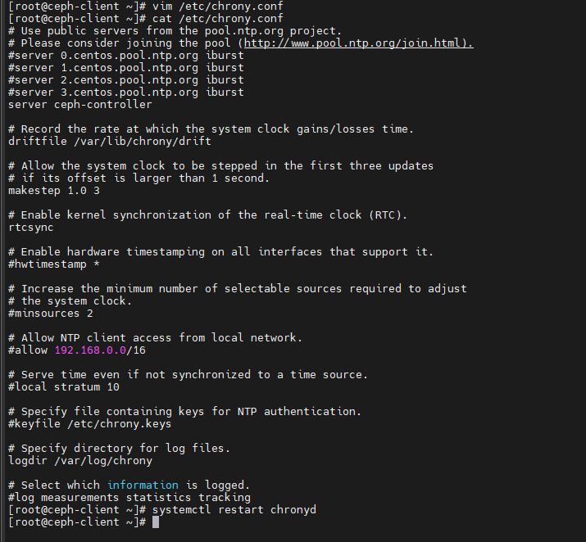

## Go to Ceph Controller Configuration

Install the Ceph release package and Ceph deployment tools:

sudo rpm -Uvh https://download.ceph.com/rpm-mimic/el7/noarch/ceph-release-1-1.el7.noarch.rpm

yum update -y && sudo yum install ceph-deploy python2-pip -y

Generate SSH keys for the cephadm user:

su - cephadm

ssh-keygen

Hit enter to accept the defaults.

Copy the SSH keys to the other nodes:

ssh-copy-id cephadm@ceph-compute01

ssh-copy-id cephadm@ceph-compute02

ssh-copy-id cephadm@ceph-monitor

ssh-copy-id cephadm@ceph-client

Create an SSH configuration file to specify the username to use when SSHing to the other nodes:

vim ~/.ssh/config

Add the following lines:

Host ceph-compute01

Hostname ceph-compute01

User cephadm

Host ceph-compute02

Hostname ceph-compute02

User cephadm

Host ceph-monitor

Hostname ceph-monitor

User cephadm

Host ceph-client

Hostname ceph-client

User cephadm

Adjust the permissions on the SSH configuration file:

chmod 644 ~/.ssh/config

Test the SSH configuration:

ssh cephadm@ceph-monitor

ssh cephadm@ceph-compute01

ssh cephadm@ceph-compute02

## Ceph Cluster Configuration (Execute these commands as the cephadm user on the Ceph controller)

Create a new directory for the Ceph cluster and navigate into it:

mkdir ceph_cluster

cd ceph_cluster

Create a new cluster:

ceph-deploy new ceph-monitor

Edit the Ceph configuration file:

vim ceph.conf

Add the line `public network = 192.168.xxx.xxx/24`, replace `192.168.15.0/24` with your local network.

Please note, you will need to replace placeholders like `192.168.xxx.xxx` with your actual values.

Install Ceph on the nodes:

ceph-deploy install ceph-controller ceph-compute01 ceph-compute02 ceph-monitor

## Initialize the Monitor and Create the Ceph Storage Cluster

Initialize the monitor:

ceph-deploy mon create-initial

Deploy the Ceph client admin keyring:

ceph-deploy admin ceph-controller ceph-compute01 ceph-compute02 ceph-monitor

Create Ceph manager daemons:

ceph-deploy mgr create ceph-compute01 ceph-compute02

List the disks available:

ceph-deploy disk list ceph-compute01 ceph-compute02

Prepare and activate the OSDs (Replace `/dev/sdb`, `/dev/sdc`, and `/dev/sdd` with the appropriate disk names):

ceph-deploy osd create --data /dev/sdb ceph-compute01

ceph-deploy osd create --data /dev/sdc ceph-compute01

ceph-deploy osd create --data /dev/sdd ceph-compute01

ceph-deploy osd create --data /dev/sdb ceph-compute02

ceph-deploy osd create --data /dev/sdc ceph-compute02

ceph-deploy osd create --data /dev/sdd ceph-compute02

ceph-deploy osd create --data /dev/sdb ceph-compute03

ceph-deploy osd create --data /dev/sdc ceph-compute03

ceph-deploy osd create --data /dev/sdd ceph-compute03

Install Ceph on the client and distribute the admin keyring:

ceph-deploy install ceph-client

ceph-deploy admin ceph-client

## Verify the Ceph Storage Cluster

Check the health of the Ceph cluster and its detailed status:

sudo ceph health

sudo ceph health detail

sudo ceph -s

35. Create a Ceph storage pool:

sudo ceph osd pool create rbd 200 3 --->(replica)

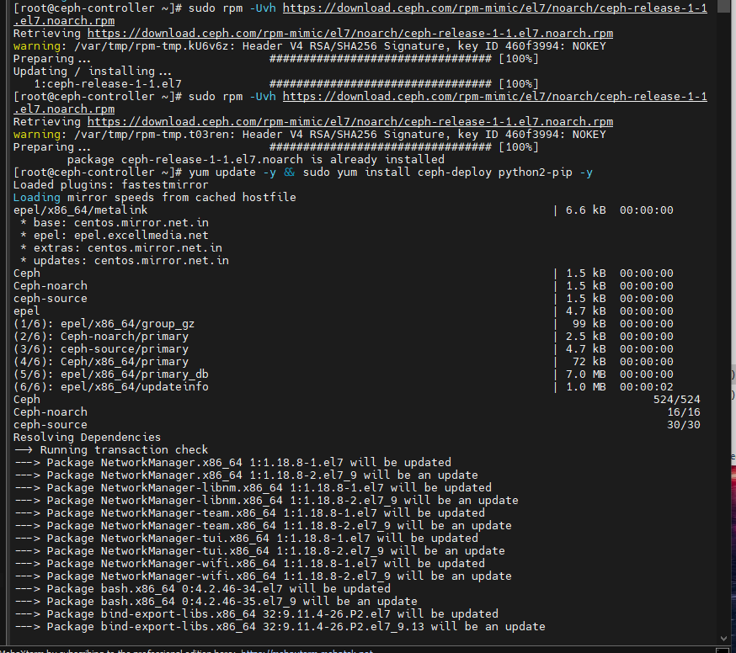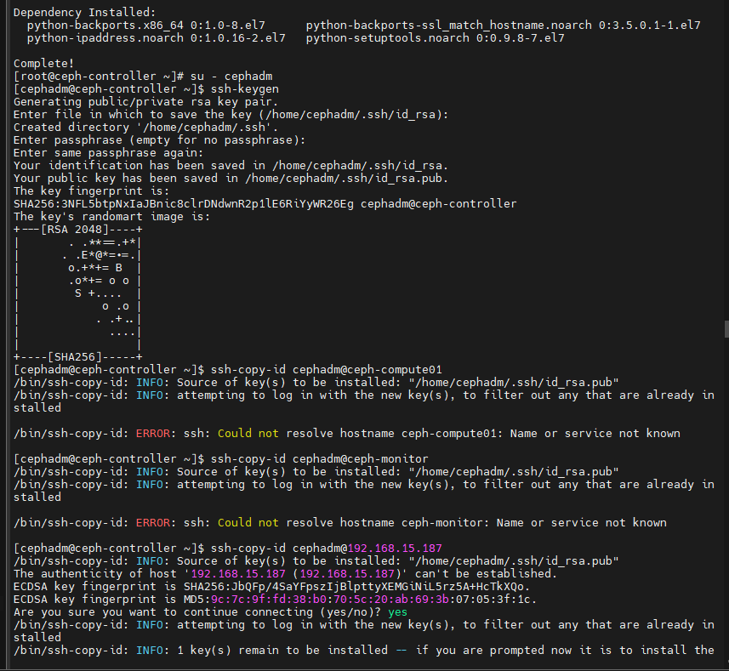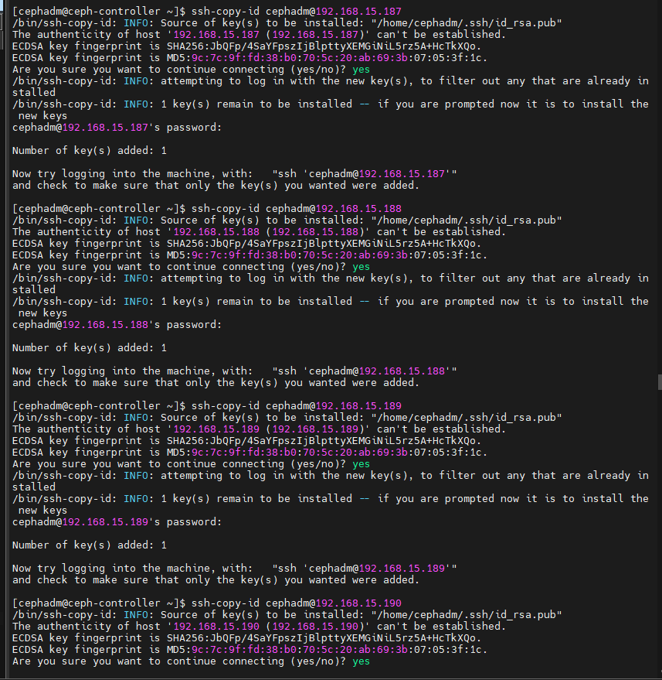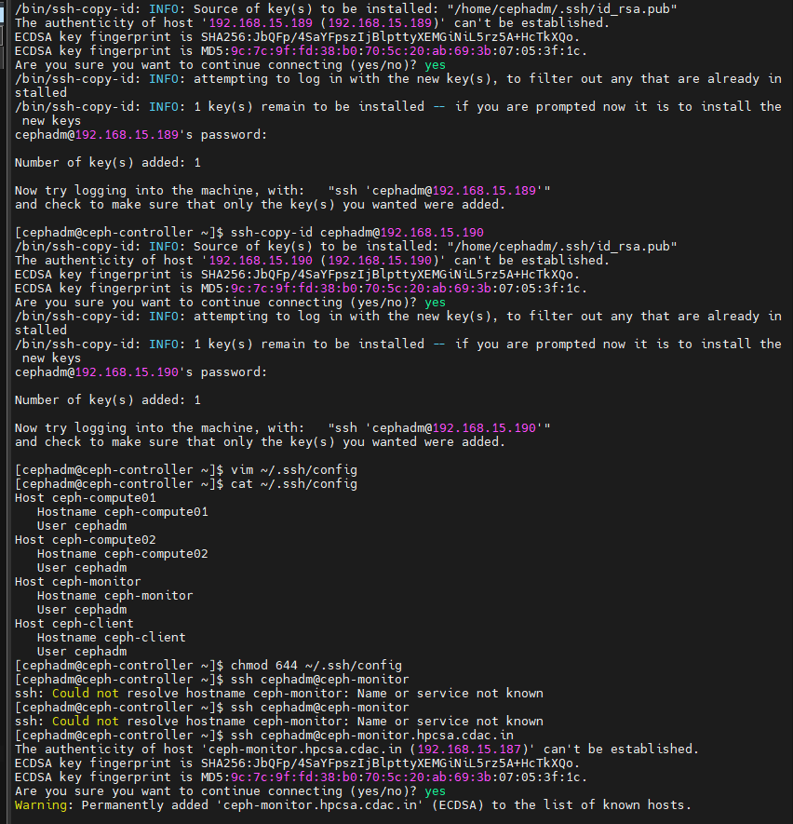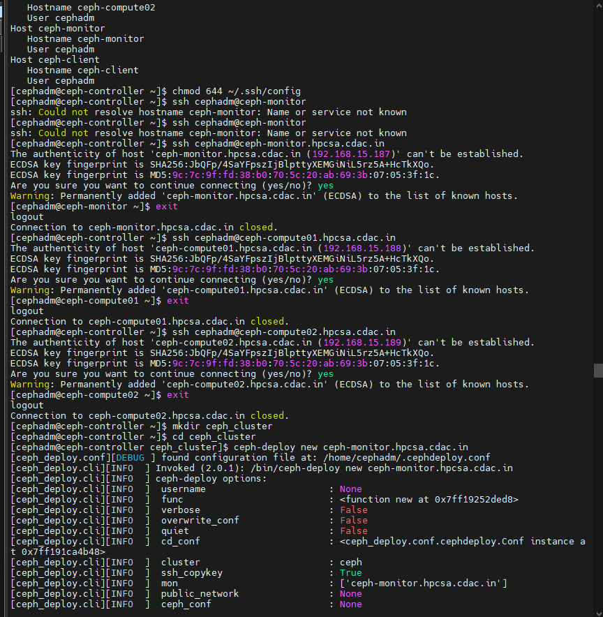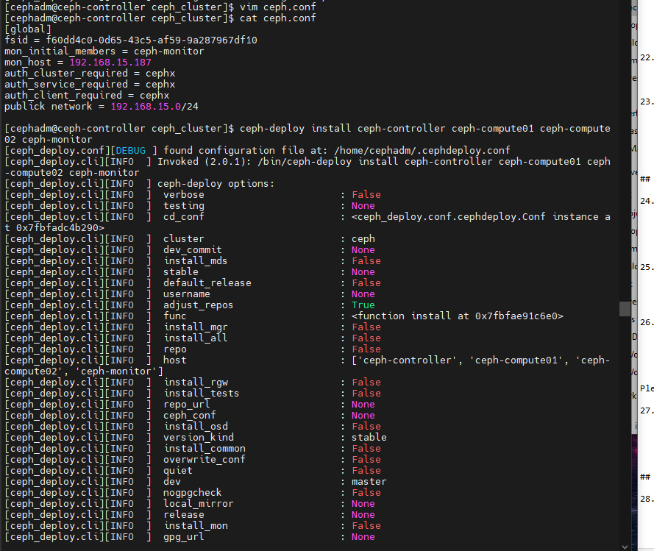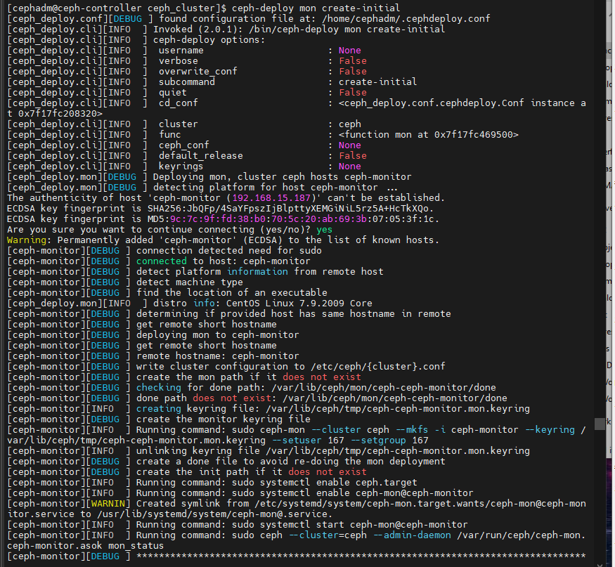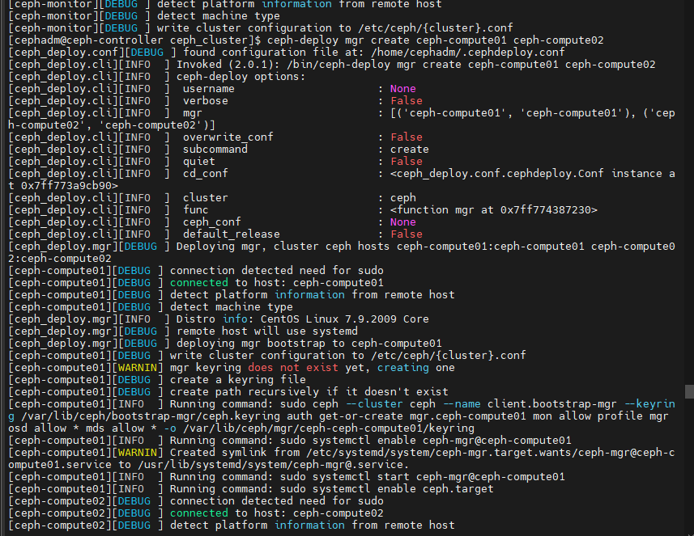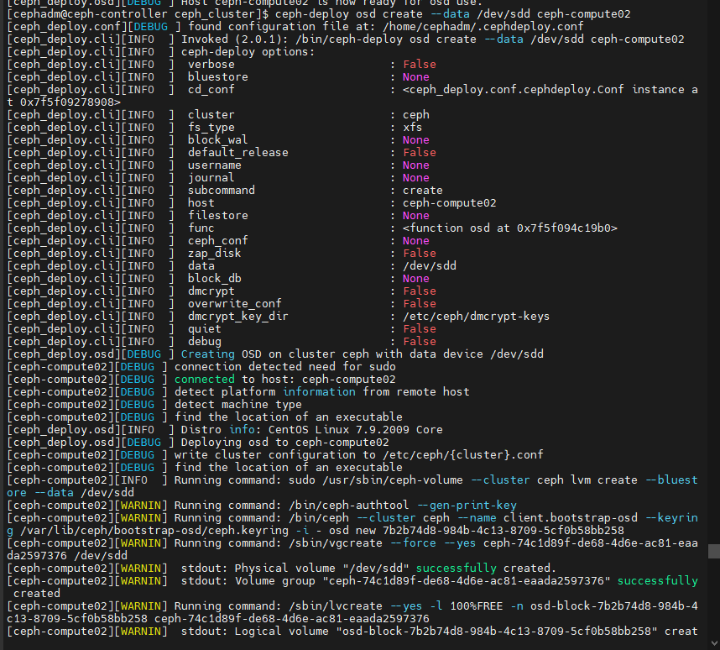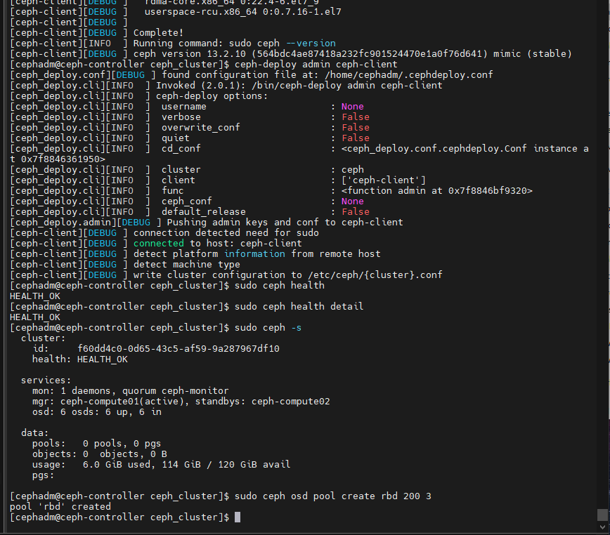

Go to client machine 🡪

## Ceph Client Configuration -------------->> run cmds in clients only

On the client, create a new block device, disable features that are not compatible with the kernel RBD driver, and map the block device:

rbd create disk01 --size 4096

rbd ls -l

modprobe rbd

rbd feature disable disk01 exclusive-lock object-map fast-diff deep-flatten

rbd map disk01

rbd showmapped

Create a filesystem on the new block device, create a mount point, and mount the block device:

mkfs.xfs /dev/rbd0

mkdir -p /mnt/mydisk

mount /dev/rbd0 /mnt/mydisk

df -h

dd if=/dev/rbd0 of=file1.txt bs=1024 count=220040

